**Zhi Chang Mart (制张 市场)**

**Zhi Chang** is a Chinese supermarket in Indonesia opened by **Zou** **Zhi Chang**(**候制张**). As the business grows, **Zhi Chang** plans to improve its service by developing a **POS** (**Point of Sales**) **system** that can help them to manage their business activity within the supermarket.

Below is the business flow that is required to be covered by the system.

**Transaction Management**

Every transaction the customer made will be **recorded** in the supermarket system. There are two kinds of transactions that can be made, **normal transaction** and **bill payment transaction**. Normal transaction occurs when the customer is buying the **products available** in the supermarket (onsite), such as shampoo, packaged food, soft drinks, etc. Whereas, paying bill transactions occurs when customers want to use **bill payment services** such as electric token, telephone bill, pulse, etc.

To increase the customer experience, the transaction system must support **purchase return**, which occurs when the customer wants to **change the purchased product** because of defective products, expired products, or other reasons. To change the purchased product, **authorization code** is required from the Storage Team and it must be at most seven days after the purchase. To request authorization code, the customer must provide his/her invoice and the cashier will input the invoice id, the reason, and other required information that may support the process. The product that was returned will be **updated** in the storage system, and each transaction occurs will **decrease** the quantity in the storage with the respective products.

Payments that accepted here are **Cash**, **Debit Card**, and **Credit Card**. Customers that have **membership** **card**, can use their membership to **collect points** according to the calculation of the total payments made. Customers that **want to be a member** of **Zhi Chang** must fulfill the minimum purchase and provide his identity such as **Name**, **Place** & **Date of Birth**, **Phone Number**, and **Email**(**optional**). The **membership card** has a **QR Code** that can be scanned on the transaction. When there is a **promo** for the menu chosen by the customer, the promo will **automatically** be **applied** to the system. Customers can also **use vouchers** at the payment, but vouchers **cannot be used more than once** and can only be used according to the **validity period**.

+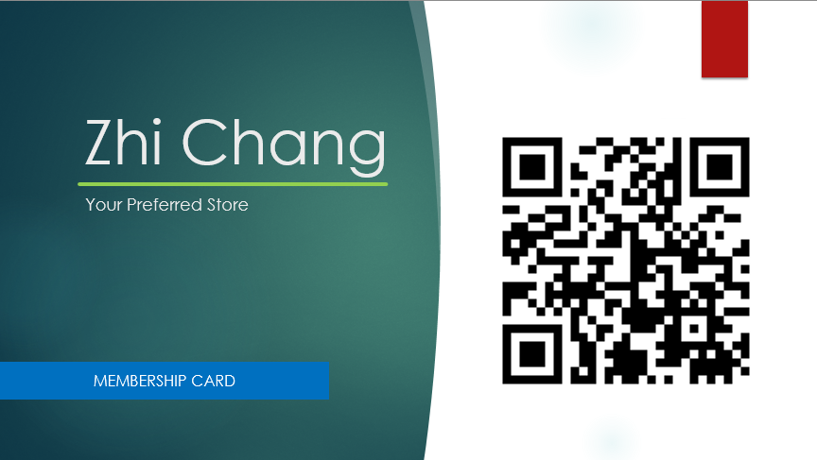

**Storage Management**

Inventory Team can restock the products by buying from the supplier or distributor. Each distributor has its own schedule (to visit the store via sales) and the distributor will come to visit the store as **scheduled**. For example, distributor Indofood will visit the store every Monday, where distributor Unilever will visit the store every Wednesday. When the distributor comes, the inventory team can **request to order products** to restock the storage. The requested products will be delivered to the store **depends on the schedule** and the inventory team will **record every product delivered** into the system. It’s important to note that each restock request **must be reported** first to the Financial Team and **must be accepted** by the Financial Team before requesting to distributor. In times of emergency, the inventory team can **call the distributor directly** to request a restock without having to wait for the distributor to visit. Therefore, the inventory team is responsible to **record the distributor or supplier information**, such as name, phone, email, and other required information based on your analysis.

The inventory team can also see supermarket storage. Each item in storage has its own measuring unit (pcs, liters, kg, etc), a **restock** **point** that can be **adjusted**, and the inventory team can also see the **status** of an item currently, whether it needs to restock or not. The inventory team is also responsible to **report a defective product** (damaged or expired) to the distributor and **request for a return**. Every defective product and the process of return is **recorded** in the system. To help the inventory team for monitoring the inventory products, each product will have a **stock card**, which consists of the information about the unit price and quantity, and other information. Based on your analysis, please **choose** whether the method used in stock card should be *FIFO (First In First Out)*, LIFO (Last In First Out), or WAC (Weighted Average Cost).

**Promo & Event Management**

Sometimes, a product may have a promo or event going on that held by the producer. For example, the producer of Pediasure Milk has a *buy ten get one* promotion, or the producer of Bebelac Milk held an event where customers can *collect stamps* for each transaction the customer made that can be exchanged with a reward provided by the producer. All transactions involving promo or event must be **recorded** in the system and **automatically displayed** in the invoices. The Marketing & Sales team must collaborate with Storage Team to **monitor all physical rewards** and manage them, including recording the reward given by the distributor, reporting missing reward, and providing information about the reward (ex: terms and condition).

Besides the external promo or event, the system must support internal promo or event. The Marketing & Sales team can see **list** **of customers** who have become members of the restaurant and inform the members about ongoing promotions, also distributing some existing vouchers. The Marketing & Sales team will distribute **vouchers** to customer(s) who have the most points in each year. The voucher created will have a **QR code** with minimum purchase to use the voucher. The Marketing & Sales team will conduct **promo** management in the form of a discount for certain items at the specified time. The discount will automatically be applied to the system so that the cashier does not need to enter the promo that is running manually.

**Human Resource Management**

HR Manager is responsible to handle all the staff data. He/she will **manage the recruitment** of the new employee and must **record all data** required. The manager is also responsible to handle about the employee that about to **resign** to open a new position for the new employee that will be recruited. Whenever there is an open job, the **job vacancy** will be announced. Every candidate that interested will be selected through some process before they are accepted as a new employee.

HR manager also manages any **violation** done by the staff, which will be **recorded** on the system, and the manager has a right to **fire** the staff based on the system. Then, HR Manager is also responsible to manage employee **shifts and salaries**. Every certain time, HR Manager **must** input the employee shift to the system and the employee can view them in their system account. Employees can also send a **salary raise request** to the HR Manager. An employee’s salary can be raised on HR Manager **approval** and the HR Manager **must** also send the salary raise request to the Finance Team. Besides that, the employee can also send leaving permit requests to the HR Manager due to some reasons such as sick leave, family events leave, or any personal reasons. HR Manager can **accept or decline** the leave permit request and the employee can **view** the HR Manager response.

**Accounting & Financial Management**

The system can **calculate the expense** used such as employee salary, electric bill, facilities, etc, and **calculating the revenue** for a **certain period**. Any expense used in every department must be requested to the Finance Team, the requester must include the invoice of the expense. The finance team is responsible to analyze profit, manage expense, and other required financial operations. To help the finance team, the system will support **data visualization**, which displays data analytics in charts.

The system also supports accounting for **calculating taxes**. Based on income tax tariff article 4 verse 2 (Tarif PPh Pasal 2 Ayat 4) the **final income tax is 0.5%**. Calculate your income by decreasing revenue with expenses. To support taxable enterprise (PKP), the system must have a feature to **record the tax invoice** (Faktur Pajak) that can be obtained from the distributor and a **bookkeeping feature**. Accounting Team can do the bookkeeping for every **certain period** (can be every day, every month, etc).

**Reporting Feature**

To help the business owner, company, or government to make prompt decisions, including making and planning plans, reporting would be a very crucial feature in the system. Reports in the system include transaction report, membership report, product report, human resource report, expense, revenue and profit report, and tax report.

* **Transaction Report**

Provides data about all transaction that recorded in the system. Transaction report is used to detect and investigate suspected market abused, future strategies to increase products sale, and as a dataset for mining data for further analysis.

* **Membership Report**

Provides data about all membership transaction and information recorded in the system. Membership report is used to help the Promo & Event Teams to give a voucher to the customer with membership and further analysis to increase the loyalty of the customer.

* **Products Report**

Provides data about bought products, sold products, damaged products, returned products, and expired products. Products report is used to monitor and manage the storage, such as restocking, replacement product request to the distributor, and further analysis to decide plans (for example the products is not selling very well, therefore, the product may be dropped for sales).

* **Human Resource Report**

Provides data about employee recruitment, raise salary request, employee firing, employee performance, and employee leave request. Human Resource report is used to improving workforce performance, recruiting procedures, and other relevant HR processes.

* **Expense, Revenue and Profit Report**

Provides in detail list of expense used, revenue obtained, and the calculated profit. The profit and loss report is an important financial statement. The report details the ability of a business to manage its profits by cutting profits and driving revenue.

* **Tax Report**

Provides all tax related information. This report will be used by the Accounting Team to present the tax information to the Financial Team for further processing and documentation.

**Super Admin**

The Super Admin has all the privileges to access the system and the super admin can also **manage** what menu that can be **accessed** by any employee. If the employee forgot their password, he/she can send a **forgot password request** to Super Admin and the Super Admin will help the employee to **restore his/her password randomly**. The employee can **change his/her password** in their own profile menu.

IMPORTANT NOTES:

* Analyze which data can be shown to another department and which are not. Only show the necessary data to another department.
* You can write your analysis assumption in the diagram.
* You must create the application based on C# using WPF and (SQLServer/MYSQL/POSTGRE) for the database.
* Your application must have an authenticated user based on roles.
* The application must minimalize human error with great user experiences.
* All data must be **soft deleted**.
* Your application must be made **based on the analysis diagram you created**.
* You must create an analysis diagram consist of:
  + Activity Diagram (min 5 and not identical)
  + Class Diagram (Updated Class Diagram with **relationship**)
  + Use Case Diagram
  + Full Use Case Description (min 5 and not identical)
  + Multi-layer Sequence Diagram (min 5 with **fragment** and not identical)
* All diagrams must use the **Satzinger** concept.
* You can use **QR Code Reader** or other software as QR Code reader.
* Required report must be able to be **exported to Excel**.
* There must be at least **three** design patterns used in the program.

 “To Learn, To Aim, To Achieve the Finest in Our Passion”